YOU are invited to join us on the next
The Ultimate Food Field Trip Summer 2016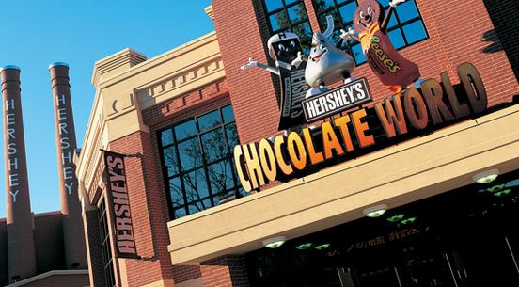

Some of our Planned Stops Include:
- Super Dawg
  - Have a classic Chicago Red Hot trimmed
- Field Museum
  - explore over 35 permanent exhibits
- Gino’s Pizza
  - enjoy a slice of authentic Chicago deep dish and sign your name on the wall when your done
- Primanti Brothers Restaurant
  - you can’t pass up their signature sandwich: meat, coleslaw and fries all piled high on top of soft Italian bread
- Hershey’s World
  - take the Great American Chocolate Tour
  - visit the attached 11 acre Zoo America
  - Make your Own Candy Bar (included)
  - free souvenir glass
- UTZ Snack Factory
  - watch various snacks being made then enjoy some free samples
- Snyder’s of Hanover Pretzel Factory Tour
  - watch over workers making pretzel and then enjoy free samples and shop the factory store
- Herr’s Potato Chip Factory Tour
  - see a potato go from spud to chip as we tour this factory
- Spangler Candy Company
  - ride along the Dum Dum trolley to see circus peanuts, lollipops, and candy canes being made
- The Chopping Block
  - enjoy a two hour hands on cooking class where the only thing better than making the food is eating it!!!!
- Shedd Aquarium
  - be amazed at the over 32,000 animals

Trip Includes:
- Coach bus
- Hotel each night (FYI: We are at our hotel each night by 6 p.m. and each hotel has a swimming pool.)
- Two meals a day
- Admission to every stop
- Bonus items or discounts at stops
- Trip T-shirt

Your Own Expenses Include:
- Souvenirs
- If you want more food than two meals a day
- If you want to upgrade to more activities at some of our stops (please note I did plan with guidance of staff from each location)

The Basics:
- June 18-25, 2016
- Open to grades K-12; families; community members
  - ages 5 and up
- The cost of the trip will be $575 per person.
  - based on 4 persons per room

What to do next:
- We need a minimum of 55 people to sign up for the large bus
  - 47 people for the smaller bus (additional cost of $22 p. person if we go with the smaller bus)
- A down payment of $100 per person is due by October 1.
  - Note: If you fund raise enough to get your trip for free, you will get your $100 down payment back!!!
- Final payment won’t be due until approximately 1 month before the trip after all fundraising is done. (May 15, 2016)

There you have it! A couple final thoughts to leave with you. I don’t have all the eating places listed. I also hoping to work in a few additional stops. Many who went with us last time were able to easily raise enough money to lower the cost per person by $100-200. Others raised enough money to the point where their trip was FREE. We need to fill the bus to make this trip happen. Please share this with family and friends. If you have any questions or comments PLEASE talk with me. The last two trips we took were amazing. Let’s make this one just as outstanding!

You can contact me at:

kfederwitz@gapps.edgar.k12.wi.us
715-352-2352 (school)
715-687-8018 (home)
715-316-2130 (cell)

Thank you for showing interest!
Kristine Federwitz
Family and Consumer Economics Teacher
Edgar High School

